**PRACTICUM REPORT**

**ALGORITHM AND DATA STRUCTURES**

**MODUL 4 : SEARCHING**



**Disusun Oleh :**

**ONIC AGUSTINO**

**L200234275**

**X**

**INFORMATICS ENGINEERING**

**FACULTY OF COMMUNICATION AND INFORMATICS**

**UNIVERSITAS MUHAMMADIYAH SURAKARTA**

**YEARS 2024/2025**

**1.11 Questions**

1.Create a search function that, instead of returning True/False, returns all location indexes of the elements searched. So, for example, in the student list on page 49 we look for students who come from Klaten, we will get [6, 8]. If what you are looking for is not found, this function will return an empty list.

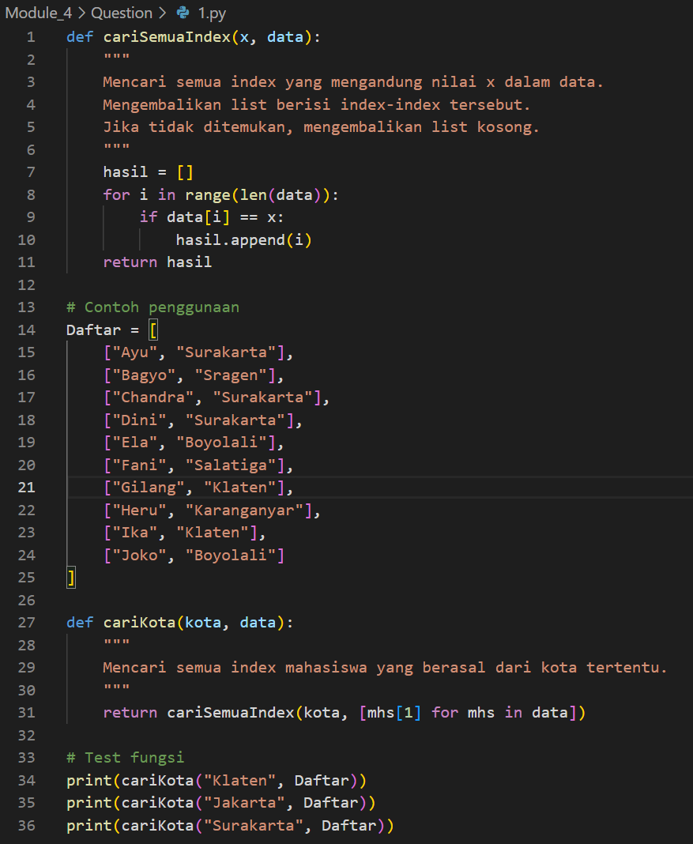

Picture 1.1 the code 1.py



Picture 1.2 the output

2. From the list of students above, create a function to find the smallest pocket money among them.

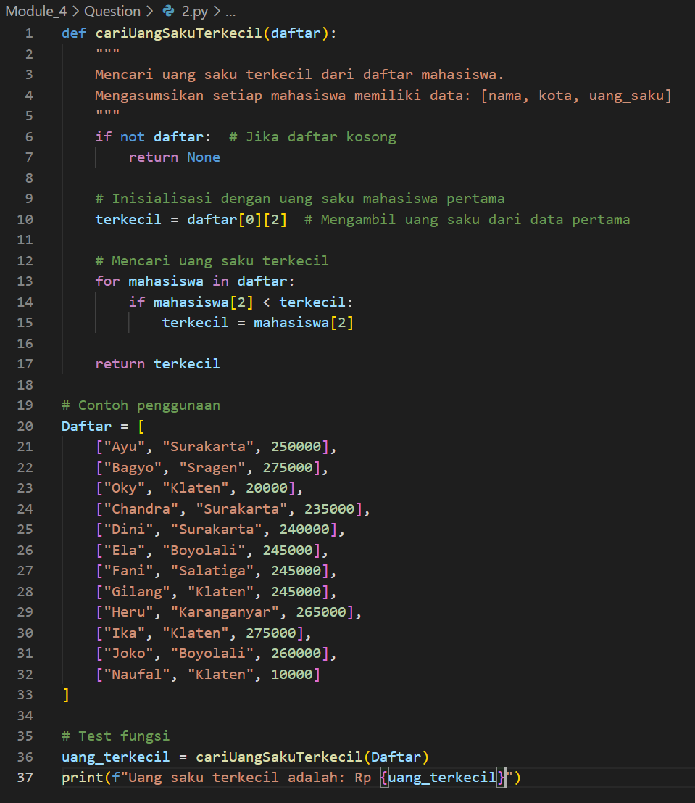

Picture 2.1 the code 2.py



Picture 2.2 the output.

3. Change the program above to return the student object that has the smallest allowance. If there is more than one student whose pocket money is the smallest, all student objects are returned.

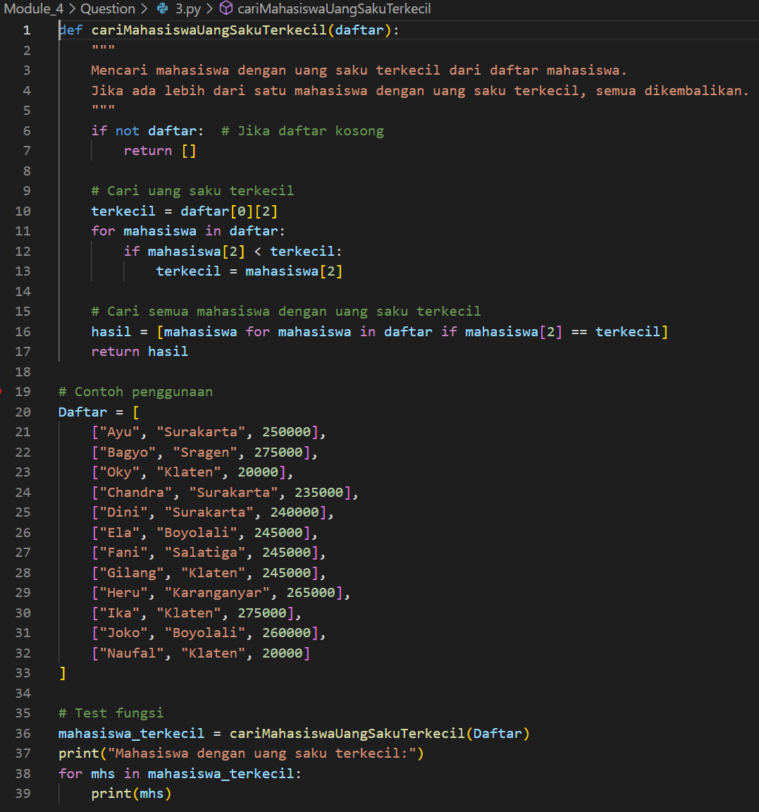

Picture 3.1 the code 3.py



Picture 3.2 the output.

4. Create a function that returns all student objects whose allowance is less than 250000.

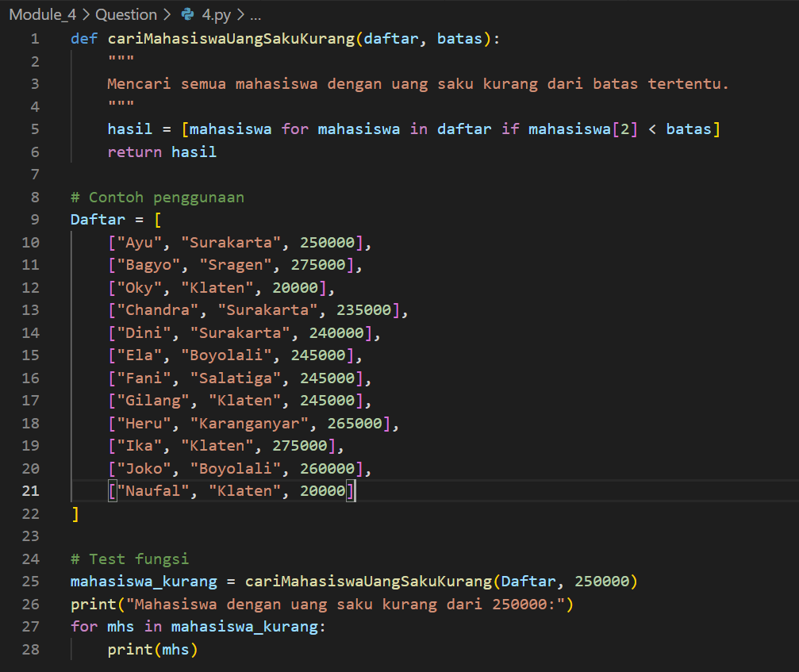

Picture 4.1 the code 4.py

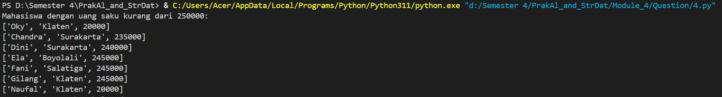

Picture 4.2 the output.

5. Write a program to search for an item in a linked list.

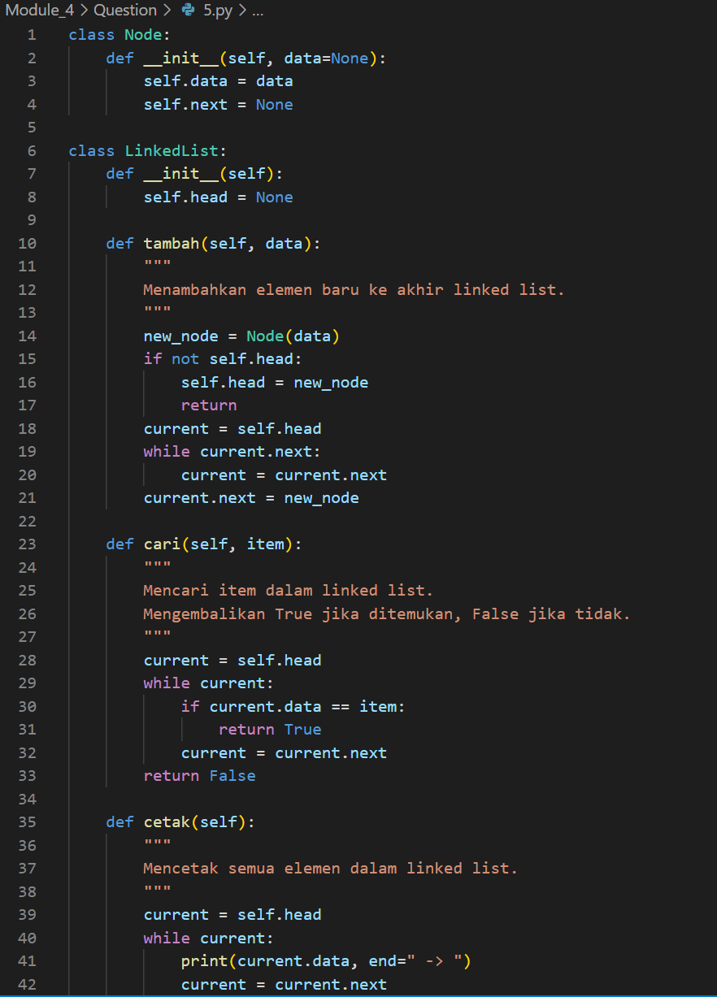

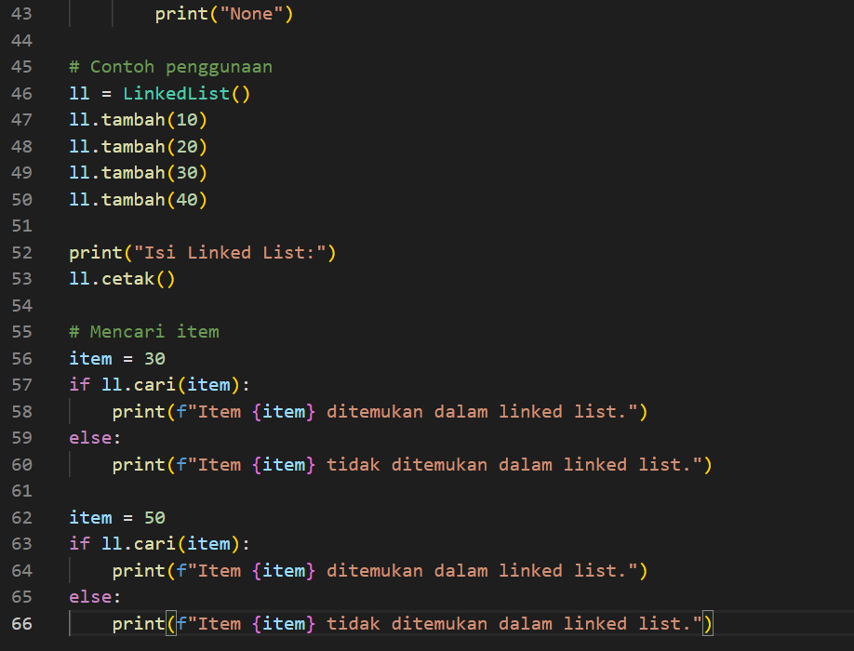

Picture 5.1 the code 5.py



Picture 5.2 the output.

6. Binary search. Change the function binSe on page 54 to return the index of the location of the element found. If you don't find it, you will return it False.

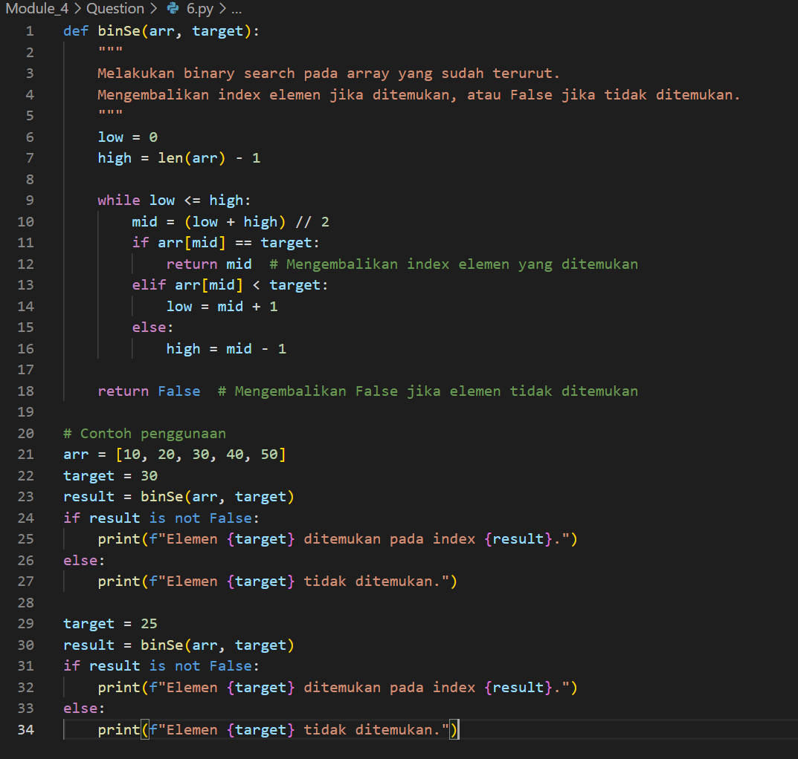

Picture 6.1 the code 6.py



Picture 6.2 the output.

7. Binary search. Change the function binSe to return all the location indexes of the elements found. Example: looking for the number 6 in the list [2, 3, 5, 6, 6, 6, 8, 9, 9, 10,11, 12, 13, 13, 14] will return [3, 4, 5]. Because it's already sorted, "just look at the left and right".

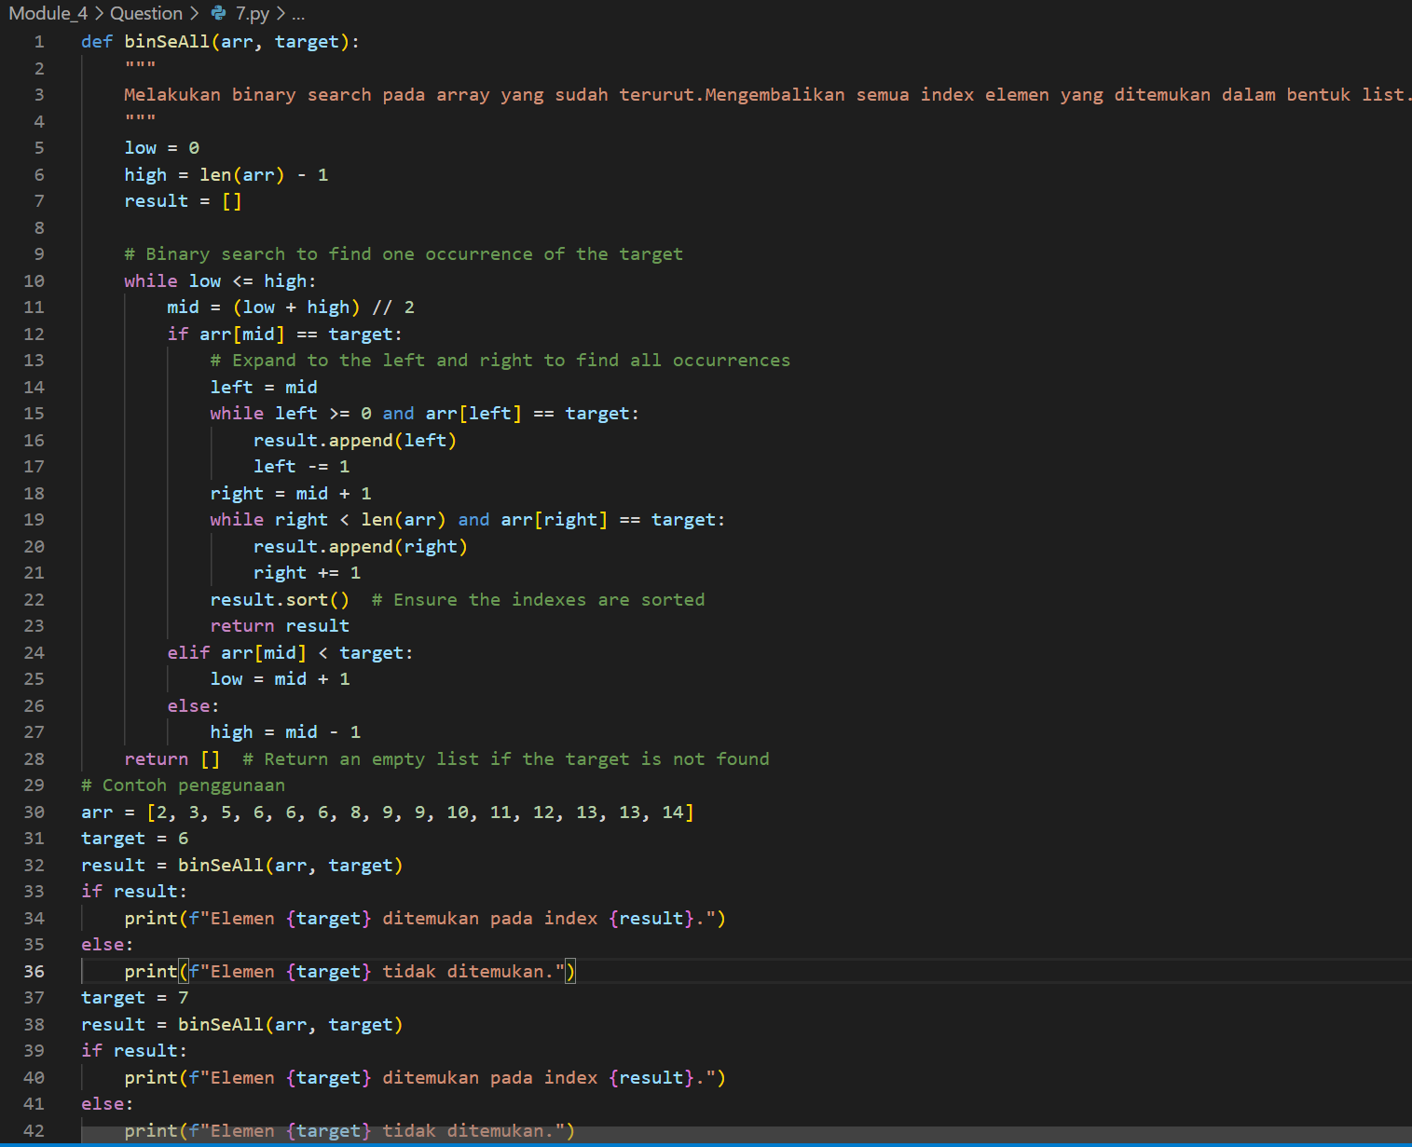

Picture 7.1 the code 7.py



Picture 7.2 the output.

8. In the number guessing game that you created in Chapter 1 (questions number 12, page 19), If the number to be guessed is between 1 and 100, the maximum number of guesses should be 7. If it is between 1 and 1000, the maximum number of guesses is 10. Why is that? What's the pattern?

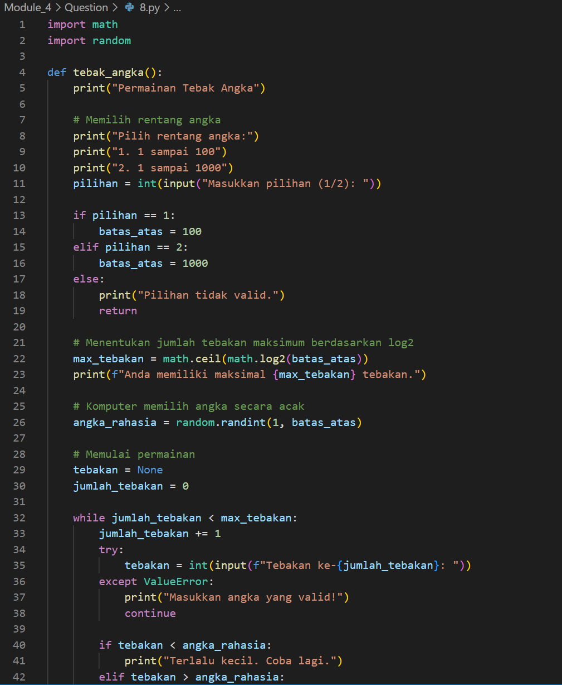

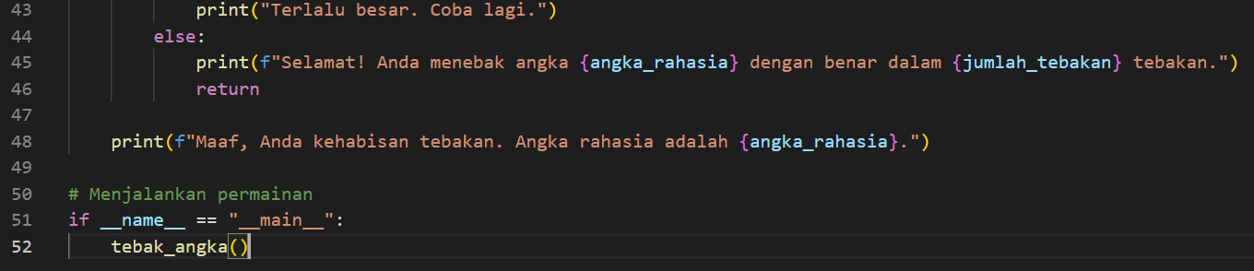

Picture 8.1 the code 8.py

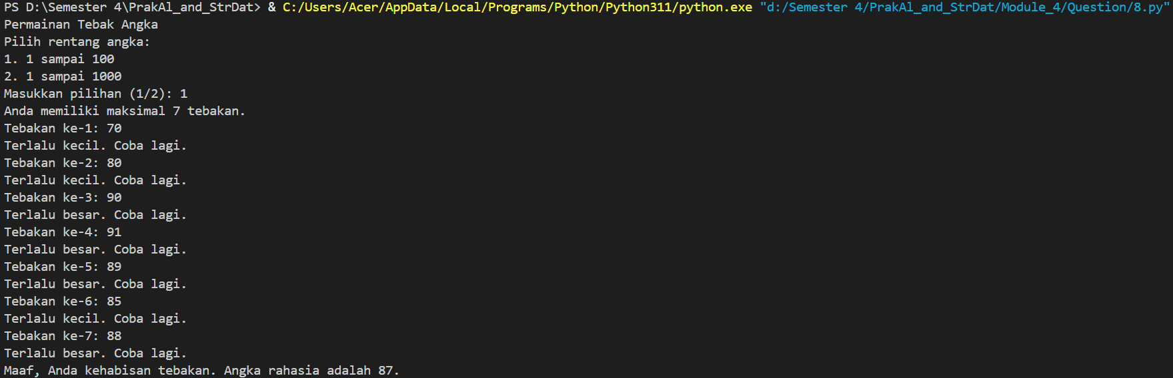

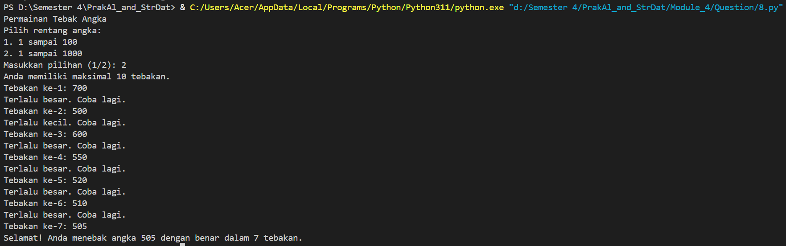

Picture 8.2 the output.

Format penulisan laporan :

1. Kertas ukuran A4 dengan margin 2,5 cm ditiap sisi
2. Jenis font Times new roman (judul/ subjudul 12, paragraft 11)
3. Format pengumpulan dalam bentuk PDF!
4. Dibuat berdasar dengan template yang sudah diberikan dan rapi.